Name Date
Stage 9 End of unit 13 test

1 Avel and Bronte stand by post P.
Avel walks on a bearing of 130 º for 40 m.
Bronte walks on a bearing of 215 º for 30 m.

a Show both of their journeys on the same scale drawing on the right.
Use a scale of ‘1 cm represents 10 m’. [2]
b On your scale drawing, measure the distance between Avel and Bronte at the end
of their walk.
At the end of their walk, how far apart are Avel and Bronte in real life?

km [2]
2 Two lighthouses are 120 km apart. Lighthouse A is west of lighthouse B.
A ship is on a bearing of 075 º from lighthouse A and 290 º from lighthouse B.
In the space, draw a scale diagram to show the position of the ship.
Use a scale of 1 : 2 000 000. [4]

3 Sadhaana cycles on a bearing of 275 ° for 24 km.
She then cycles on a bearing of 220 ° for 8 km.
a In the space, make a scale drawing of Sadhaana’s journey. [3]
Use a scale of ‘1 cm represents 4 km’.

b How far must Sadhaana now cycle to return to her starting point?

[2]
c On what bearing must Sadhaana now cycle to return to her starting point?
[1]
4 O is the point (0, 0), M is the point (18, 21) and N is the point (35, 25).
Circle the correct answer, A, B or C.
a The point that lies of the way along OM is A (12, 14) B (6, 7) C (15, 18)
b The point that lies of the way along ON is A (7, 5) B (30, 20) C (28, 20) [2]
5 O is the point (0, 0) and D is the point (32, 48). The points A, B, C and D are equally spaced along the line OD. Work out the coordinates of C.

[3]
6 F is the point (2, 7) and H is the point (11, 13). G is the point that lies of the way along FH.
Work out the coordinates of G.

[3]
7 The diagram shows shape A on a coordinate grid.
On the diagram, draw the image of A after each of these combinations of transformations.
a Reflection in the line x = 1,
followed by the translation .
Label the image B.

b Rotation 90° anticlockwise, centre (−2, 1),
followed by a reflection in the line y = −1.
Label the image C. [4]
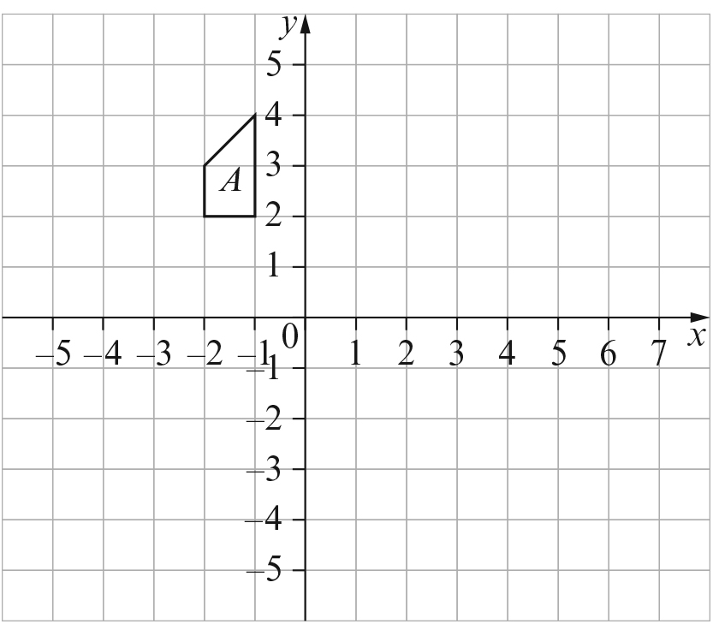
8 The diagram shows triangles G, H, I and J on a coordinate grid.
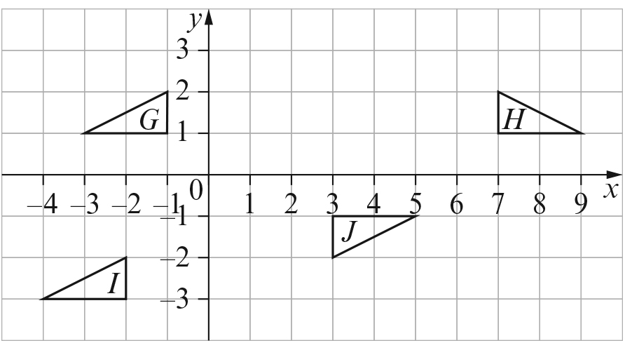
a Describe the reflection that transforms shape G to shape H.
[1]
b Describe the translation that transforms shape G to shape I.
[1]
c Describe the rotation that transforms shape G to shape J.
[1]
d Describe a combined transformation that transforms shape I to shape J.

[2]
e Describe a combined transformation that transforms shape J to shape H.

[2]
9 Enlarge the shape using a scale factor of 2 and centre of enlargement shown.
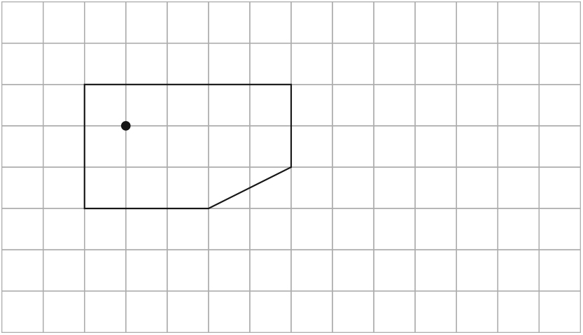 [2]
10 A rectangle, R, has a perimeter of 16 cm and an area of 16 cm².
The rectangle is enlarged by a scale factor of 3 to become rectangle T. Work out:
a the perimeter of rectangle T
[1]
b the area of rectangle T.
[2]
11 The diagram shows shapes F and G.
Complete this statement:
Shape G is an enlargement of shape F, scale factor and
centre of enlargement at ( , ). [2]
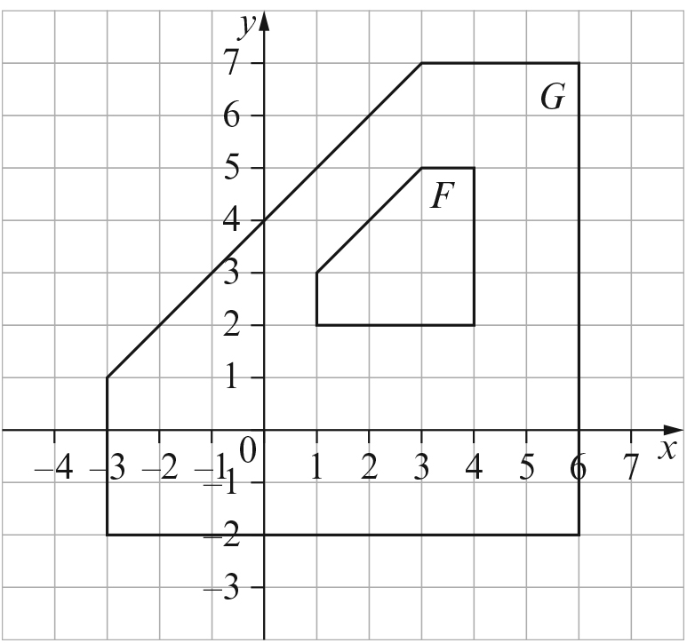
[Total: 40 marks]

END OF TEST

